 

# Placement Empowerment Program

***Cloud Computing and DevOps Centre***

Write a Python Script to Monitor an Application: Create a Python script that sends periodic HTTP requests to your application and alerts you if it’s down.

Name:Shahana.M.S Department: ADS



**Introduction**

Application monitoring is essential for ensuring high availability and performance. By creating a Python script to periodically send HTTP requests to an application, you can detect downtime and receive alerts in case of failures. This proactive approach helps in quickly identifying and resolving issues before they impact users.

**Objective**

* Develop a Python script to monitor an application’s uptime.
* Send periodic HTTP requests to check application availability.
* Alert the user if the application is down or experiencing issues.
* Automate monitoring for improved system reliability.

**Overview**

The script will continuously send HTTP requests to a specified URL at regular intervals. If the response status indicates downtime (e.g., no response or HTTP status code 500+), the script will trigger an alert via email, SMS, or logging. This ensures timely notifications for quick troubleshooting.

**Importance**

* **Minimizes Downtime:** Early detection of application failures prevents prolonged outages.
* **Enhances Reliability:** Continuous monitoring ensures high system availability.
* **Automates Health Checks:** Reduces the need for manual monitoring.
* **Improves User Experience:** Quick issue resolution minimizes disruptions for users.
* **Facilitates Proactive Maintenance:** Helps in identifying performance bottlenecks before they escalate.

# Step-by-Step Overview

## Step 1:

Open command prompt and type the following code to check what is the version of the installation

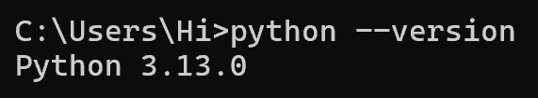

## Step 2:

We need the requests library. In the same Command Prompt, type:

Screenshot 2025-02-12 182117.png

## Step 3:

Open **Notepad** and type the following code and Save the file as

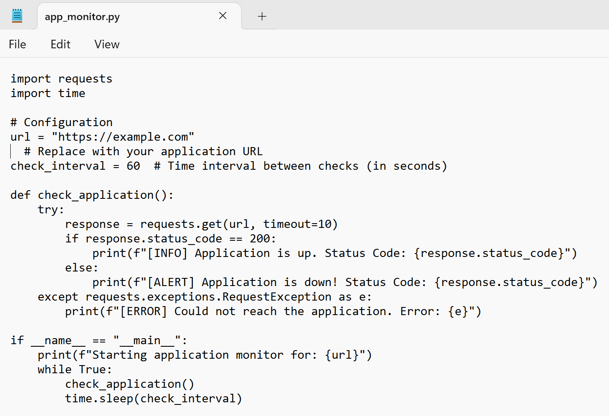**app_monitor.py** on your Desktop.

## Step 4:

* Then again in command prompt ,do the following command to change directory or path
* Run the Script

### Screenshot 2025-02-12 182128.pngpython app_monitor.py

**You should see output like this:**

**Starting application monitor for: https://example.com**

**[INFO] Application is up. Status Code: 200**

**This means the script successfully checked** [**https://example.com**](https://example.com) **and found it online.**

* **Status Code: 200 indicates the website is reachable and working fine.**

**If the application is down or unreachable, you may see:**

**[ALERT] Application is DOWN! Status Code: 500**

**or**

**[ERROR] Failed to reach the server. Connection timed out.**

**This means the application is either facing issues or not responding.**

**To stop the monitoring, press Ctrl + C in the Command Prompt window, to exit use Ctr+X**

**Outcome**

* A functional Python script that continuously monitors an application.
* Automatic alerts when the application goes down, ensuring quick response.
* Improved system uptime and reliability.
* Enhanced user satisfaction by reducing servi